|  |  |
| --- | --- |
| Ex. No: 2 | GREATEST OF THREE NUMBERS USING PHP |
| Date: 18.07.2023 |

# AIM: Write a PHP program to find greatest of three numbers using PHP.

## PROGRAM:

## great.php

<html>

<head><title>Greatest of three Numbers</title></head>

<form method="POST" action="three.php">

A Value: <input type="text" name="t1"><br><br>

B Value: <input type="text" name="t2"><br><br>

C Value:<input type="text" name="t3"><br><br>

<input type="Submit" value="RESULT">

</form>

</html>

## three.php

<?php

echo "<center><h3>GRESTEST OF THREE NUMBERS:</h3></center>";

$a=$_POST["t1"];

$b=$_POST["t2"];

$c=$_POST["t3"]; if(($a>$b)&&($a>$c))

echo "$a is greater";

else if($b>$c)

echo "$b is greater"; else

echo "$c is greater";

?>

## OUTPUT:

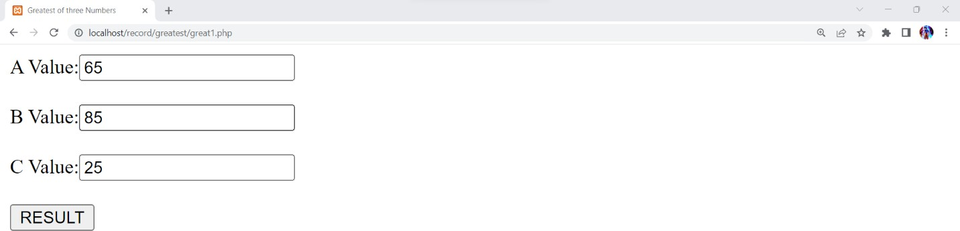

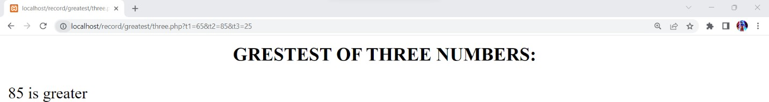

**RESULT:** Thus the above program is executed successfully and output is verified.

|  |  |
| --- | --- |
| Ex. No: 3 | Script Using Switch Case |
| Date: 25.07.2023 |

AIM : Write a PHP program to execute Switch cases using using script.

## PROGRAM:

<html>

<body>

<?php

$favcolor="red";

switch($favcolor)

{

case"red";

echo"your favourite color is red!";

case"blue";

echo"your favourite color is blue!";

case"green";

echo"your favourite color is green!";

break;

default:

echo"your favourite color is neither red,blue (or) green!";

}

?>

</body>

</html>

Output:

your favourite color is red!your favourite color is blue!your favourite color is green!

**RESULT:** Thus the above program is executed successfully and output is verified.

|  |  |
| --- | --- |
| Ex. No: 4 | Changing Background Color |
| Date: 28.07.2023 |

AIM: Write a PHP program to change Background color.

## PROGRAM:

<html>

<body <?php if(isset($_POST['bg'])){

$bgcolor=$_POST['bg']; echo "bgcolor=$bgcolor";

}

?>>

<center><h2>Changing background color using radio button</h2></center>

<form action="" method="POST">

<center><h4>Color</h4></center>

<input type="radio" name="bg" value="red">RED<br><br>

<input type="radio" name="bg" value="green">GREEN<br><br>

<input type="radio" name="bg" value="blue">BLUE<br><br>

<input type ="submit" value="Change color">

</form>

</body>

</html>

## OUTPUT:

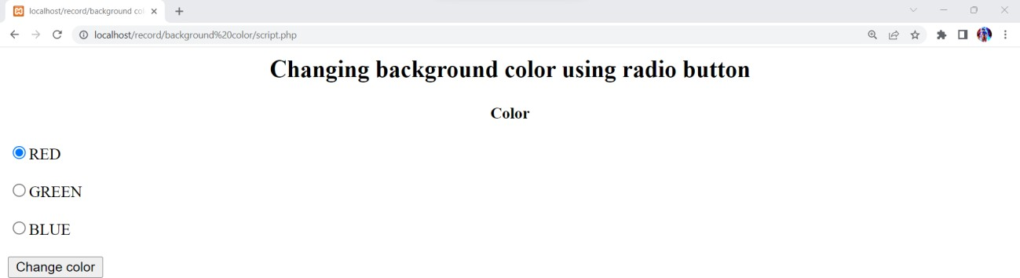

# Write a PHP Program to create validation form using form.

# PROGRAM:

# form3.html

# <html>

# <body>

# <form method="post" action="test_form.php"><br><br>

# Enter your name: <input type="text" name="name"><br><br>

# Enter your E-mail: <input type="text" name="email"><br><br>

# Website: <input type="text" name="website"><br><br>

# Comments: <textarea name="comments" rows=5 cols=20></textarea><br><br>

# Gender: <input type="radio" name="gender" value="male"> Male

# <input type="radio" name="gender" value="female"> Female<br><br>

# <input type="submit" name="submit" value="Submit">

# </form>

# </body>

# </html>

# test_form.php

# <html>

# <body>

# <?php

# echo "Name :".$_POST["name"]."<br>";

# echo "E-mail :".$_POST["email"]."<br>";

# echo "Website :".$_POST["website"]."<br>";

# echo "Comments given by user :".$_POST["comments"]."<br>";

# echo "Gender selected :".$_POST["gender"]."<br>";

# ?>

# </body>

# </html>

# Output:

